South Australia
Shop Theft (Alternative Enforcement) Act 2000
An Act to provide for certain persons accused of minor shop theft to be subject to a non-curial enforcement process with their consent as an alternative to prosecution; and for other purposes.

Contents
1 Short title
3 Interpretation
4 Issue of shop theft infringement notice
5 Consent to being dealt with under Act—goods valued at or below the prescribed amount
6 Consent to being dealt with under Act—goods valued at more than the prescribed amount
7 Failure to effectively consent
8 Withdrawal of consent
9 Alleged offender to be provided with copy of notice and caution
10 Information to be provided to victim
11 Community service
12 Breach of undertaking specified in notice
13 No prosecution if effective consent given
14 Failure to issue notice or allow effective consent not to be raised in proceedings
15 Inadmissibility of evidence of consent etc
16 Commissioner to keep records
17 Confidentiality
18 Commissioner's annual report to contain information relating to notices
Schedule 1—Shop theft infringement notice—goods valued at or below the prescribed amount
Schedule 2—Shop theft infringement notice—goods valued at more than the prescribed amount
Schedule 3—Provisions relating to community service
1 Interpretation
2 Application of Correctional Services Act 1982
3 Special provisions relating to community service
4 Chief Executive must assign community corrections officer
5 Community corrections officer may give reasonable directions
6 Extension of period for performance of community service
7 Waiver of community service requirement on notification by Chief Executive
8 Waiver of unperformed hours of community service on application
9 Increase in hours on default in performance of community service
10 Breach of undertaking to be reported to Commissioner of Police
11 Evidentiary
Legislative history

The Parliament of South Australia enacts as follows:
1—Short title
This Act may be cited as the Shop Theft (Alternative Enforcement) Act 2000.
3—Interpretation
(1) In this Act—
community corrections officer means a person who is a community corrections officer within the meaning of the Sentencing Act 2017;
CPI means the Consumer Price Index (All Groups) for the City of Adelaide published by the Australian Bureau of Statistics;
minor shop theft means theft of goods valued at or below the prescribed upper limit from a shop;
prescribed amount means—
(a) if no amount is prescribed by regulation in accordance with subsection (3)—$30; or
(b) if an amount is prescribed by regulation in accordance with subsection (3)—that amount;
prescribed upper limit means—
(a) if no amount is prescribed by regulation in accordance with subsection (3)—$150; or
(b) if an amount is prescribed by regulation in accordance with subsection (3)—that amount;
sale includes hire;
shop includes any place where goods are displayed for sale;
victim of an alleged offence of minor shop theft means the proprietor of the business in the course of which the goods in question were displayed for sale or an agent of the proprietor.
(2) For the purposes of this Act, the value of any goods the subject of an allegation of theft from a shop will be taken to be—
(a) the retail price (or the lowest retail price) of the goods at the shop on the day on which the alleged theft took place; or
(b) if, on the day on which the alleged theft took place, the goods do not have a retail price at the shop—the amount that would be the cost to the victim of replacing the goods on that day.
(3) The regulations may prescribe an amount for the purposes of the definition of prescribed amount or prescribed upper limit, provided that an amount prescribed must not exceed—
(a) in the case of the prescribed amount—$30 adjusted by the percentage variation (to two decimal points) between the CPI for the quarter immediately preceding the commencement of this section and the CPI for the quarter immediately preceding the making of the regulation and rounded to the nearest dollar;
(b) in the case of the prescribed upper limit—$150 adjusted by the percentage variation (to two decimal points) between the CPI for the quarter immediately preceding the commencement of this section and the CPI for the quarter immediately preceding the making of the regulation and rounded to the nearest dollar.
4—Issue of shop theft infringement notice
(1) If a police officer is satisfied that—
(a) an allegation of theft made against a person constitutes an allegation of minor shop theft; and
(b) the alleged offender—
(i) is aged 18 years or over; and
(ii) is not an employee of the victim; and
(c) the victim consents to the alleged offender's being dealt with under this Act; and
(d) there is no reason to suspect that the alleged theft is part of a pattern of behaviour on the part of the alleged offender or an organised scheme involving the alleged offender; and
(e) there is sufficient evidence on which a court could reasonably find the alleged offender guilty of the alleged theft,
the police officer may, instead of charging the alleged offender with theft, issue a shop theft infringement notice to the alleged offender.
(2) If a victim consents to an alleged offender being dealt with under this Act, that consent cannot be withdrawn.
(3) A shop theft infringement notice issued to an alleged offender must—
(a) if the goods the subject of the allegation are valued at or below the prescribed amount—be in the form set out in Schedule 1; or
(b) if the goods the subject of the allegation are valued at more than the prescribed amount—be in the form set out in Schedule 2.
(4) When a police officer issues a shop theft infringement notice to an alleged offender, the police officer must read to the alleged offender the information contained in Part B of the notice.
5—Consent to being dealt with under Act—goods valued at or below the prescribed amount
An alleged offender who has been issued with a shop theft infringement notice relating to goods valued at or below the prescribed amount effectively consents to being dealt with under this Act if—
(a) immediately following the issue of the notice—
(i) the alleged offender apologises to the victim at the shop, in the presence of a police officer (unless the victim indicates that he or she does not want to receive an apology); and
(ii) if the goods are no longer in the condition in which they were displayed for sale because of the actions of the alleged offender—the alleged offender, in the presence of a police officer, pays the victim the value of the goods; and
(iii) the alleged offender completes and signs the statement contained in Part C of the notice—
(A) admitting the commission of the offence described in the notice; and
(B) undertaking to submit to a caution against further offending to be administered by a police officer; and
(iv) a police officer confirms that it is appropriate that the alleged offender be dealt with under this Act by completing and signing Part D of the notice; or
(b) within 48 hours after the issue of the notice—
(i) the alleged offender personally attends at the police station specified in the notice; and
(ii) if the goods are no longer in the condition in which they were displayed for sale because of the actions of the alleged offender—the alleged offender pays the value of the goods to a police officer (which amount must be forwarded to or made available for collection by the victim); and
(iii) a police officer specifies in Part C of the notice the day and time at which the alleged offender will be required to apologise to the victim (unless the victim has indicated that he or she does not want to receive an apology); and
(iv) the alleged offender completes and signs the statement contained in Part C of the notice—
(A) admitting the commission of the offence described in the notice; and
(B) undertaking—
• to submit to a caution against further offending to be administered by a police officer; and
• if applicable, to apologise to the victim at the shop, in the presence of a police officer, on the day and at the time specified in the notice; and
(v) a police officer confirms that it is appropriate that the alleged offender be dealt with under this Act by completing and signing Part D of the notice.
6—Consent to being dealt with under Act—goods valued at more than the prescribed amount
An alleged offender who has been issued with a shop theft infringement notice relating to goods valued at more than the prescribed amount effectively consents to being dealt with under this Act if, within 48 hours after the issue of the notice—
(a) the alleged offender personally attends at the police station specified in the notice; and
(b) if the goods are no longer in the condition in which they were displayed for sale because of the actions of the alleged offender—the alleged offender pays the value of the goods to a police officer (which amount must be forwarded to or made available for collection by the victim); and
(c) a police officer specifies in Part C of the notice—
(i) the day and time at which the alleged offender will be required to apologise to the victim (unless the victim has indicated that he or she does not want to receive an apology); and
(ii) the place at which the alleged offender will be required to report to a community corrections officer for the purpose of completing a period of community service; and
(d) the alleged offender completes and signs the statement contained in Part C of the notice—
(i) admitting the commission of the offence described in the notice; and
(ii) undertaking—
(A) to submit to a caution against further offending to be administered by a police officer; and
(B) if applicable, to apologise to the victim at the shop, in the presence of a police officer, on the day and at the time specified in the notice; and
(C) to complete a period of community service specified in the notice (to be calculated at the rate of one hour for every $5, or part thereof, of the value of the goods) within the period of six months after the date on which consent is given; and
(D) for the purpose of completing a period of community service—
• to report to a community corrections officer at the place specified in the notice not later than two working days after the date on which consent is given; and
• to obey the lawful directions of the community corrections officer to whom the alleged offender is assigned; and
(e) a police officer confirms that it is appropriate that the alleged offender be dealt with under this Act by completing and signing Part D of the notice.
7—Failure to effectively consent
If an alleged offender who has been issued with a shop theft infringement notice does not effectively consent to being dealt with under this Act, the alleged offender may be charged with theft in relation to the allegation the subject of the notice.
8—Withdrawal of consent
(1) An alleged offender who has been issued with a shop theft infringement notice relating to goods valued at or below the prescribed amount and effectively consented to being dealt with under this Act immediately following the issue of the notice may withdraw that consent at any time within 48 hours of the issue of the notice by personally attending at the police station specified in the notice and advising a police officer, in writing, that consent is withdrawn.
(2) If an alleged offender withdraws consent in accordance with this section, the alleged offender will be treated as if he or she had never effectively consented to being dealt with under this Act.
(3) This section does not apply if an alleged offender has paid the victim the value of the goods.
9—Alleged offender to be provided with copy of notice and caution
An alleged offender who has been issued with a shop theft infringement notice and effectively consented to being dealt with under this Act must be provided with—
(a) a copy of the duly completed and signed shop theft infringement notice; and
(b) a notice setting out the words of the caution administered to the alleged offender.
10—Information to be provided to victim
If a police officer issues a shop theft infringement notice to an alleged offender, the officer must—
(a) ask the victim of the alleged offence whether he or she wishes to be provided with information in relation to the manner in which the alleged offence has been dealt with; and
(b) if the victim indicates that he or she does wish to have that information—ensure that the victim is provided with that information.
11—Community service
The provisions set out in Schedule 3 apply in relation to the performance of community service in accordance with an undertaking specified in a shop theft infringement notice.
12—Breach of undertaking specified in notice
(1) A person who has been issued with a shop theft infringement notice and effectively consented to being dealt with under this Act must not, without reasonable excuse (proof of which lies on the person), breach an undertaking specified in the shop theft infringement notice.
Maximum penalty: $1 250
(2) In proceedings for an offence against this section, an apparently genuine document purporting to be a shop theft infringement notice, or a copy of a shop theft infringement notice, issued under this Act and duly completed and signed constitutes, in the absence of proof to the contrary—
(a) proof that the person named as the alleged offender in the notice has effectively consented to being dealt with under this Act; and
(b) proof of the terms of the undertakings specified in the notice.
(3) In proceedings for an offence against this section, an apparently genuine document purporting to be a certificate executed by a community corrections officer performing duties at a specified place certifying that a specified person did not report to a community corrections officer at that place during a specified period constitutes, in the absence of proof to the contrary, proof of the matters so certified.
13—No prosecution if effective consent given
A person who has been issued with a shop theft infringement notice and effectively consented to being dealt with under this Act is not liable to prosecution for an offence of theft in relation to the allegation the subject of the notice.
14—Failure to issue notice or allow effective consent not to be raised in proceedings
No argument may be put in proceedings before a court on a charge of theft that a shop theft infringement notice should have been issued to the defendant, or that the defendant should have been allowed to effectively consent to being dealt with under this Act, in relation to the allegation the subject of the proceedings.
15—Inadmissibility of evidence of consent etc
(1) Subject to subsection (2), the fact that a person who was issued with a shop theft infringement notice admitted committing the offence the subject of the notice by, or for the purposes of, effectively consenting to being dealt with under this Act may not be adduced in evidence or cited or referred to in any proceedings other than by or with the consent of the person.
(2) Subsection (1) does not apply in relation to—
(a) proceedings for an offence against section 12; or
(b) disciplinary proceedings against a police officer relating to conduct in connection with the shop theft infringement notice or the issue of the notice.
16—Commissioner to keep records
(1) The Commissioner of Police must keep a record of—
(a) the name of an alleged offender who has been issued with a shop theft infringement notice under this Act and has effectively consented to being dealt with under this Act; and
(b) the details of allegations contained in the notice; and
(c) the terms of the undertakings specified in the notice.
(2) A record required under this section must be kept for at least five years after the date on which effective consent to being dealt with under this Act was given.
17—Confidentiality
(1) A person who is, or has been, engaged in the administration of this Act must not disclose information relating to a shop theft infringement notice or the issue of a shop theft infringement notice obtained (whether by that person or otherwise) in the administration of this Act except—
(a) to members of the police force for police record keeping or law enforcement purposes; or
(b) to the alleged offender to whom the notice was issued (or to the alleged offender's legal representative); or
(c) to the victim of the alleged offence in accordance with section 10; or
(d) as required for the purposes of the Police Complaints and Discipline Act 2016; or
(e) as required for the purposes of any legal proceedings.
Maximum penalty: $10 000.
(2) This section does not derogate from section 15.
(3) This section does not prevent a person from divulging statistical or other information that could not reasonably be expected to lead to the identification of a person who has been issued with a shop theft infringement notice.
18—Commissioner's annual report to contain information relating to notices
(1) The Commissioner of Police must, on or before 30 September in each year, prepare a report on the operation and administration of this Act during the period of 12 months that ended on the preceding 30 June.
(2) A report required under this section must be incorporated in the annual report of the Commissioner of Police required under the Police Act 1998.

Schedule 1—Shop theft infringement notice—goods valued at or below the prescribed amount
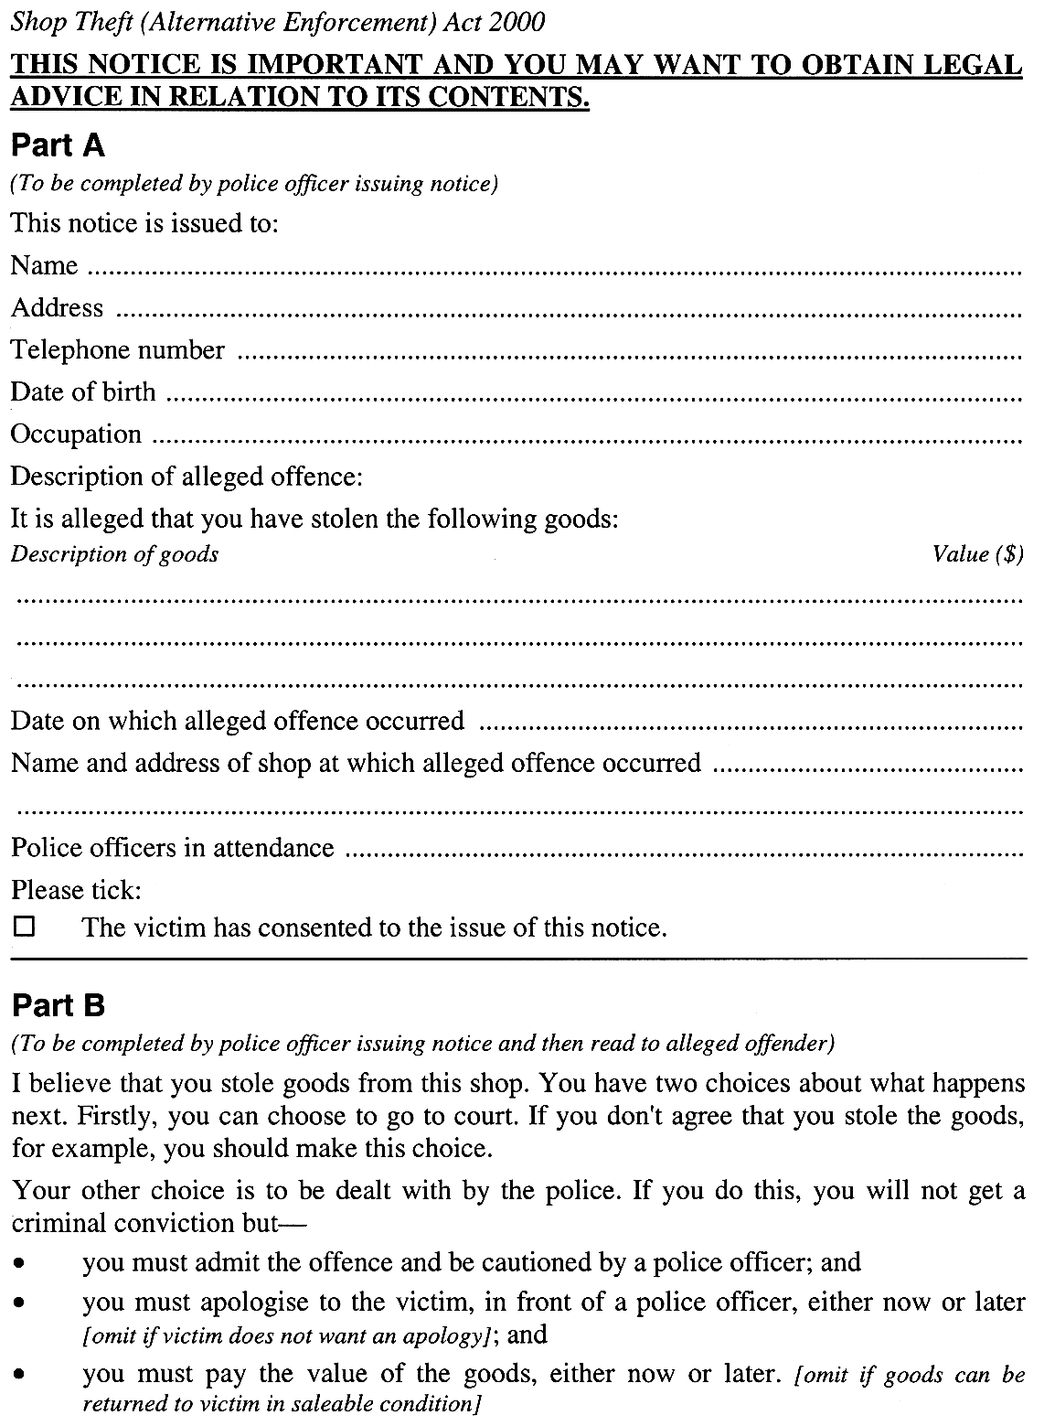
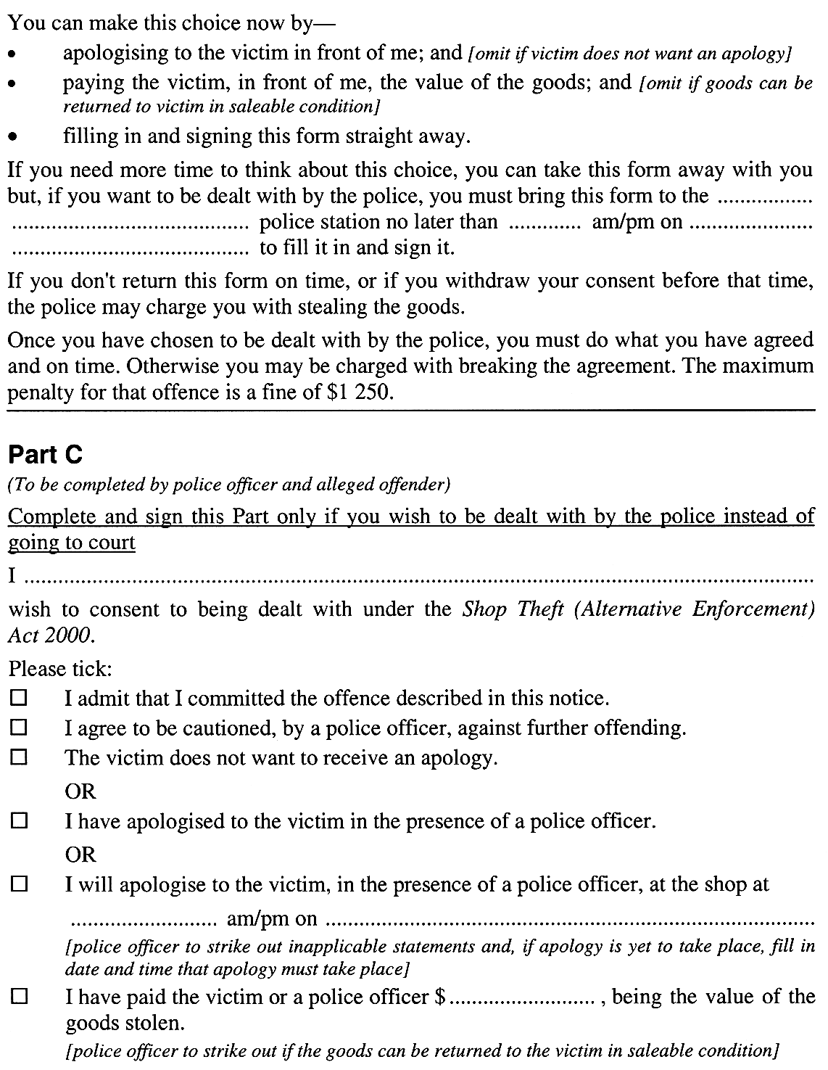
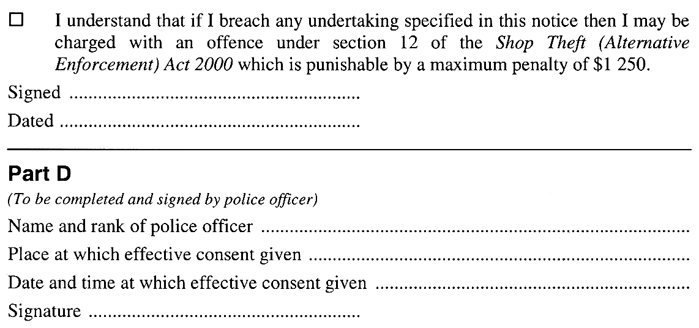

Schedule 2—Shop theft infringement notice—goods valued at more than the prescribed amount
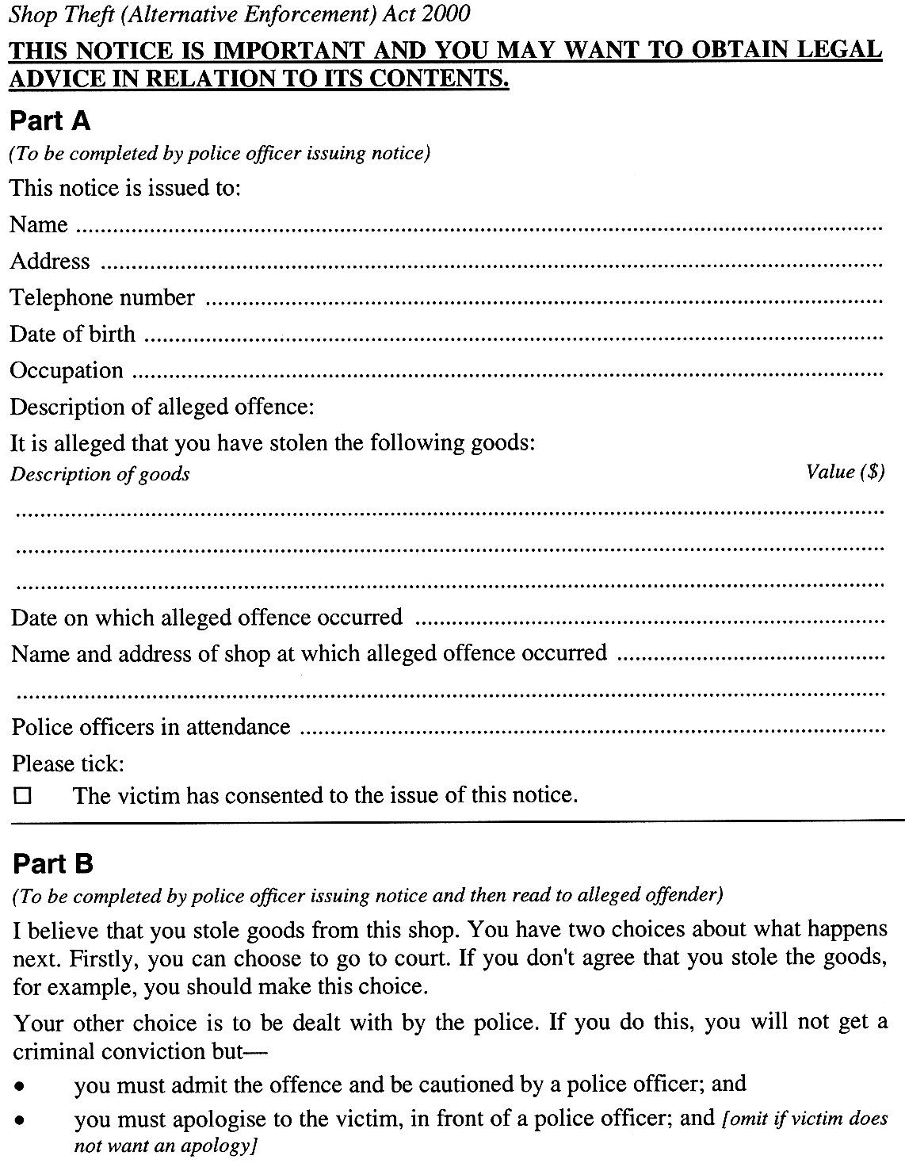
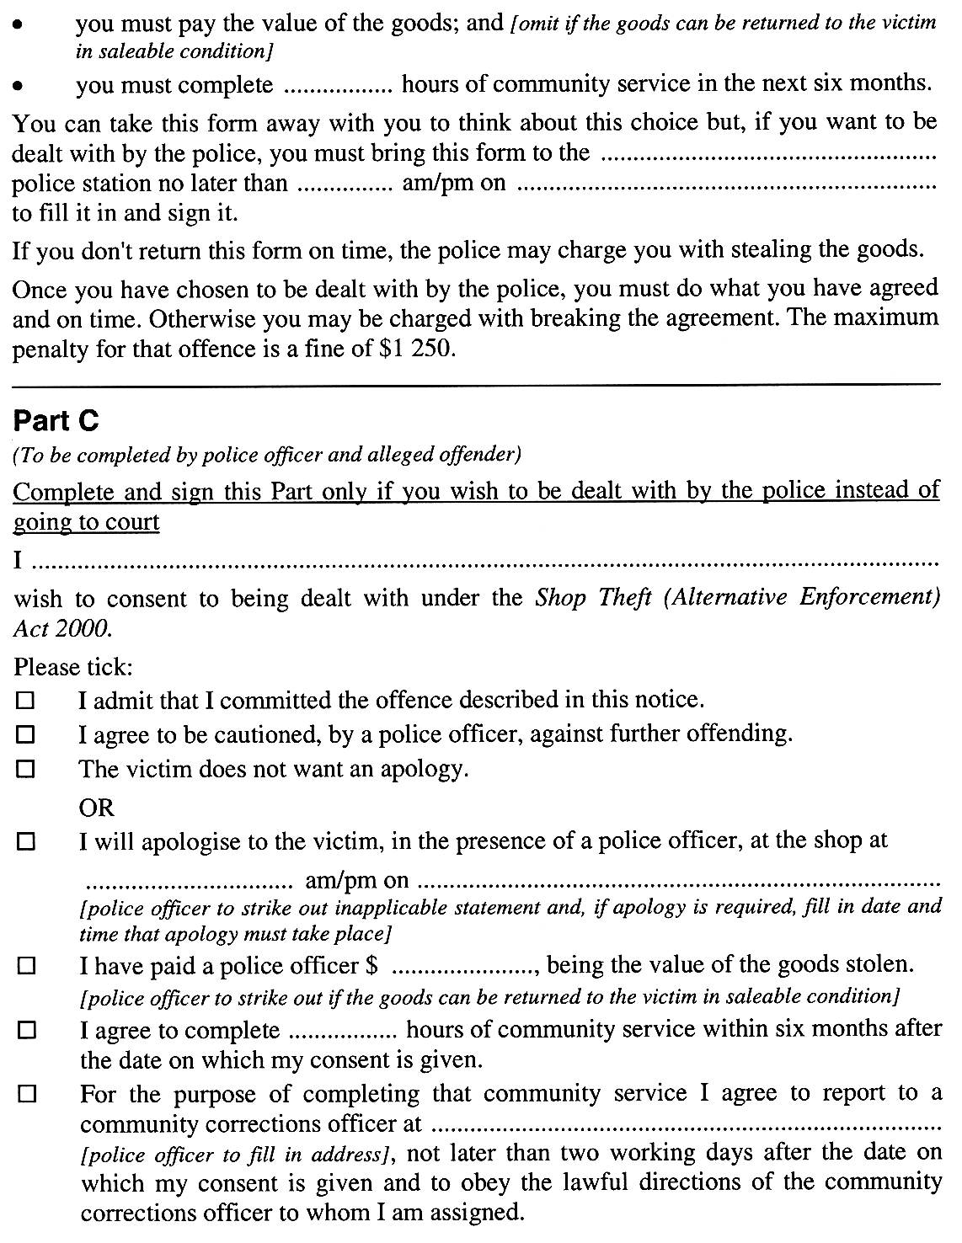
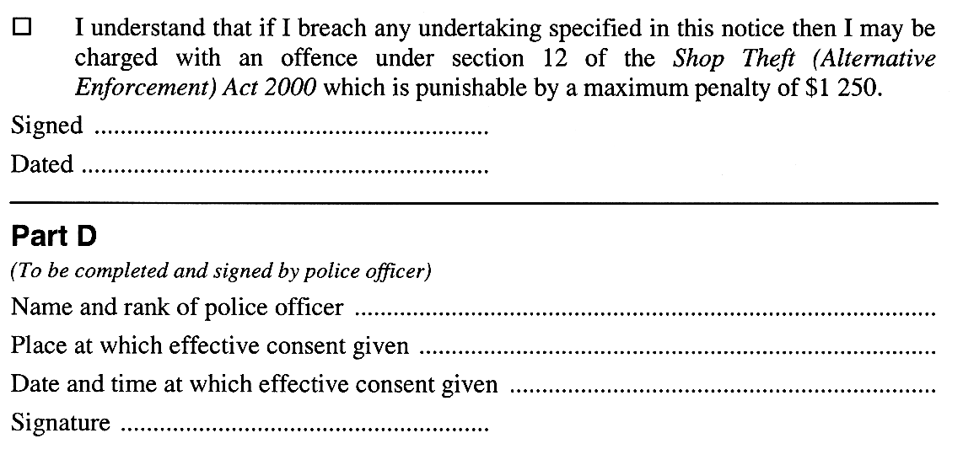

Schedule 3—Provisions relating to community service
1—Interpretation
In this Schedule—
Chief Executive means the CE within the meaning of the Sentencing Act 2017;
Minister means the Minister performing functions under Part 4 of the Sentencing Act 2017.
2—Application of Correctional Services Act 1982
A person required to perform a period of community service in accordance with an undertaking specified in a shop theft infringement notice will be taken to be an offender for the purposes of Division 4 of Part 2 of the Correctional Services Act 1982.
3—Special provisions relating to community service
The following provisions apply in relation to community service to be performed by a person in accordance with an undertaking specified in a shop theft infringement notice:
(a) the person is required to perform community service for not less than 4 hours each week and on such day, or days, as the community corrections officer to whom the person is assigned may direct;
(b) the person may not be required to perform community service for more than 24 hours in any week;
(c) the person may not, except in circumstances approved by the Minister, be required to perform community service for a continuous period exceeding eight hours;
(d) if, on any day, a period of community service is to exceed four continuous hours, the next hour must be a meal break;
(e) the person may not be required to perform community service at a time that would interfere with his or her remunerated employment or with a course of training or instruction relating to, or likely to assist him or her in obtaining, remunerated employment, or that would cause unreasonable disruption of the person's commitments in caring for his or her dependants;
(f) the person may not be required to perform community service at a time that would cause him or her to offend against a rule of a religion that he or she practises;
(g) the attendance of the person at any educational, recreational or rehabilitative course or program approved by the Minister will be taken to be performance of community service;
(h) the person will not be remunerated for the performance of any community service in accordance with the notice.
4—Chief Executive must assign community corrections officer
(1) The Commissioner of Police must ensure that, when a person effectively consents to a shop theft infringement notice that requires the performance of community service, a copy of the notice is promptly provided to the Chief Executive.
(2) The Chief Executive must, on receiving a copy of a shop theft infringement notice that requires the performance of community service, and may thereafter from time to time, assign the person to whom the notice relates to a community corrections officer.
(3) The Chief Executive must ensure that the person is notified in writing of the name of the community corrections officer to whom he or she has been assigned and, if necessary, of the place and time at which he or she must first report to that officer.
(4) It is the duty of a community corrections officer to endeavour to ensure that any person assigned to the officer for the purpose of performing community service in accordance with an undertaking specified in a shop theft infringement notice complies with the undertakings relating to community service specified in the notice.
5—Community corrections officer may give reasonable directions
A community corrections officer to whom a person is assigned for the purpose of performing community service in accordance with an undertaking specified in a shop theft infringement notice—
(a) may give reasonable directions to the person—
(i) requiring the person to report to a community service centre or other place at certain times; or
(ii) requiring the person to perform certain projects or tasks as community service; or
(iii) requiring the person to undertake or participate in courses of instruction at a community service centre or other place; or
(iv) requiring the person to behave in a particular manner while undertaking community service; and
(b) may give the person other directions of a kind authorised by the Minister, either generally or in relation to that person.
6—Extension of period for performance of community service
(1) Where a shop theft infringement notice requires the performance by a person of community service, the Minister may, on application by the person or the Chief Executive, by instrument in writing, extend the period within which the community service is to be performed.
(2) The Minister cannot, on an application under subclause (1), extend the period within which the community service is to be performed by more than six months.
(3) If the period within which community service is to be performed in accordance with a shop theft infringement notice is extended under this clause, the undertaking specified in the notice will be taken to be varied accordingly.
7—Waiver of community service requirement on notification by Chief Executive
(1) The Chief Executive must notify the Minister if the Chief Executive forms the opinion that it is not possible or reasonably practicable for a person to perform community service in accordance with an undertaking specified in a shop theft infringement notice (either at all or within the period specified in the notice or any extension of that period that may be granted under clause 6)—
(a) because the person—
(i) suffers from a physical or mental infirmity; or
(ii) has been imprisoned or remanded in custody in relation to an offence; or
(iii) is subject to some other requirement for the performance of community service; or
(b) for some other sufficient reason.
(2) On receiving a notification under subclause (1), the Minister may, by instrument in writing, waive compliance with the requirement to perform community service, or a specified number of hours of community service.
(3) If the Minister waives compliance with the requirement to perform community service or a number of hours of community service under this clause, the undertaking specified in the notice will be taken to be varied accordingly.
8—Waiver of unperformed hours of community service on application
(1) If, on the application of a person required to perform community service in accordance with an undertaking specified in a shop theft infringement notice, the Minister is satisfied—
(a) that, although some hours of community service remain unperformed, the person has substantially complied with the undertaking; and
(b) that there is no apparent intention on the person's part to deliberately evade his or her obligations under the notice; and
(c) that sufficient reason exists for not insisting on performance of some or all of those hours,
the Minister may, by instrument in writing, waive compliance with the requirement to perform those hours, or a specified number of them.
(2) The Minister cannot exercise his or her powers under subclause (1) to waive performance of more than ten hours under the one notice.
(3) If the Minister waives compliance with the requirement to perform a number of hours of community service under this clause, the undertaking specified in the notice will be taken to be varied accordingly.
9—Increase in hours on default in performance of community service
(1) If the Minister is satisfied that a person has breached an undertaking specified in a shop theft infringement notice by failing to obey a direction of a community corrections officer to whom the person is assigned, the Minister may deal with the breach by increasing, by notice in writing served personally, the number of hours of community service that the person is required to perform in accordance with the notice.
(2) If the Minister exercises his or her powers under subclause (1) to increase the number of hours of community service to be performed in accordance with an undertaking specified in a shop theft infringement notice—
(a) the undertaking specified in the notice will be taken to have been varied accordingly; and
(b) the person to whom the notice relates may not be prosecuted in relation to the breach.
(3) The number of hours of community service may not be increased under subclause (1) by more than 24 in aggregate.
10—Breach of undertaking to be reported to Commissioner of Police
(1) If the Minister is satisfied that a person has breached an undertaking specified in a shop theft infringement notice relating to the performance of community service, the Minister must, unless satisfied that the breach is trivial or should be dealt with under another provision of this Schedule, notify the Commissioner of Police of the breach.
(2) If proceedings are commenced alleging breach of an undertaking specified in a shop theft infringement notice relating to the performance of community service, the requirements relating to community service specified in the undertaking have no further operation.
11—Evidentiary
In any proceedings, an apparently genuine document purporting to be a certificate executed by the Minister certifying as to a matter relating to the exercise of powers by the Minister under this Schedule constitutes proof, in the absence of proof to the contrary, of the matters so certified.

Legislative history
Notes
• Please note—References in the legislation to other legislation or instruments or to titles of bodies or offices are not automatically updated as part of the program for the revision and publication of legislation and therefore may be obsolete.
• Earlier versions of this Act (historical versions) are listed at the end of the legislative history.
• For further information relating to the Act and subordinate legislation made under the Act see the Index of South Australian Statutes or www.legislation.sa.gov.au.
Principal Act and amendments
New entries appear in bold.
Year | No | Title | Assent | Commencement
2000 | 73 | Shop Theft (Alternative Enforcement) Act 2000 | 7.12.2000 | 11.11.2001 (Gazette 20.9.2001 p4212)
2002 | 26 | Criminal Law Consolidation (Offences of Dishonesty) Amendment Act 2002 | 31.10.2002 | Sch 3 (cl 7)—5.7.2003 (Gazette 15.5.2003 p1979)
2012 | 52 | Independent Commissioner Against Corruption Act 2012 | 6.12.2012 | Sch 3 (cl 72)—20.12.2012 (Gazette 20.12.2012 p5742)
2016 | 60 | Police Complaints and Discipline Act 2016 | 8.12.2016 | Sch 1 (cl 33)—4.9.2017 (Gazette 29.8.2017 p3794)
2017 | 53 | Statutes Amendment (Sentencing) Act 2017 | 28.11.2017 | Pt 18 (ss 28 & 29)—30.4.2018 (Gazette 6.2.2018 p612)
Provisions amended
New entries appear in bold.
Entries that relate to provisions that have been deleted appear in italics.
Provision | How varied | Commencement
s 2 | omitted under Legislation Revision and Publication Act 2002 | 5.7.2003
s 3
s 3(1)
community corrections officer | amended by 53/2017 s 28 | 30.4.2018
minor shop theft | amended by 26/2002 s 19(2) (Sch 3 cl 7(a)) | 5.7.2003
s 3(2) | amended by 26/2002 s 19(2) (Sch 3 cl 7(b)) | 5.7.2003
s 4
s 4(1) | amended by 26/2002 s 19(2) (Sch 3 cl 7(c)) | 5.7.2003
s 7 | amended by 26/2002 s 19(2) (Sch 3 cl 7(d)) | 5.7.2003
s 13 | amended by 26/2002 s 19(2) (Sch 3 cl 7(e)) | 5.7.2003
s 14 | amended by 26/2002 s 19(2) (Sch 3 cl 7(f)) | 5.7.2003
s 17
s 17(1) | amended by 52/2012 Sch 3 cl 72 | 20.12.2012
 | amended by 60/2016 Sch 1 cl 33 | 4.9.2017
Sch 3
cl 1
Chief Executive | substituted by 53/2017 s 29 | 30.4.2018
Minister | substituted by 53/2017 s 29 | 30.4.2018
Historical versions
Reprint No 1—5.7.2003
20.12.2012
4.9.2017

